**Wire-Frame Design**

**Stores Sales Prediction**

|  |  |
| --- | --- |
| Written By | Om Chaithanya V |
| Document Version | 1.0 |
| Last Revised Date | 12-09-2021 |

**Document Change Control Record**

|  |  |  |  |
| --- | --- | --- | --- |
| **Version** | **Date** | **Author** | **Comments** |
|  |  |  |  |
|  |  |  |  |
|  |  |  |  |
|  |  |  |  |
|  |  |  |  |
|  |  |  |  |
|  |  |  |  |
|  |  |  |  |
|  |  |  |  |
|  |  |  |  |
|  |  |  |  |
|  |  |  |  |
|  |  |  |  |
|  |  |  |  |
|  |  |  |  |
|  |  |  |  |

**Reviews**

|  |  |  |  |
| --- | --- | --- | --- |
| **Version** | **Date** | **Reviewer** | **Comments** |
|  |  |  |  |

### **Approval Status:**

|  |  |  |  |  |
| --- | --- | --- | --- | --- |
| **Version** | **Review date** | **Reviewed By** | **Approved By** | **Comments** |
|  |  |  |  |  |

**Homepage**

On the homepage the user will be able to see the heading of the project name and there will be hyperlinks of my GitHub, LinkedIn and Medium pages at the top right of the home page, and the user will enter the product and outlet details in this page. Then predict button can be used to get the result.

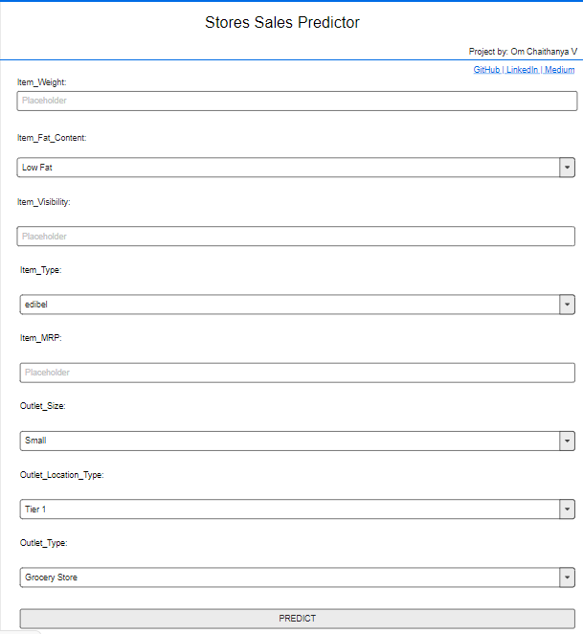

**Prediction Page**

When user clicks on predict button the next page will open which will be the result page where the prediction will be shown for the given inputs. Below is the image how the result page will look like:

